**Background Paper (BP) on the ‘Policy lessons from country experiences with health and wellbeing (SDG3) in the wake of COVID-19’**

Yesim Tozan, PhD

School of Global Public Health, New York University, New York, NY 10003, USA

NYU Research Team: Kiera Bloch, Ariadna Capasso, Tyler Y. Headley, Sooyoung Kim

(by alphabetical order)

**Notes on the extended outline**

*We include a draft of the case studies on Viet Nam and Peru to illustrate the general framework that the eventual case studies on Cuba, Oman, Nigeria, Rwanda, and Peru will follow. Upon completion of the country case studies, we will finish the background paper’s comparative analysis and conclusions.*

**Abstract**

The COVID-19 pandemic has had profound effects on health care and other societal systems, as well as the global economy. As in most pandemic and disasters, poorer developing nations have taken the hardest hits, and disadvantaged groups, particularly people living in poverty and subject to marginalization and exclusion, have suffered the most. Although the national response strategies to COVID-19 have, particularly during the initial phase of the pandemic, been largely similar in scope, the timeliness, scale, and assertiveness of the response have varied considerably across countries. In this background paper, we attempted to answer three questions: How have different countries, particularly those that are resource-constrained, responded to the COVID-19 pandemic? What have been the main similarities and differences in policies and approaches that countries have taken to tackle this novel public health threat? And what key policy lessons can be drawn from these countries’ experiences for future public health crises? To draw conclusions from the various COVID-19 response strategies and approaches taken by governments to mitigate the multifaceted impacts of the pandemic, we compiled country case studies on Cuba, Nigeria, Oman, Rwanda, Peru, and Viet Nam. These six countries were selected based on their varying levels of national progress towards Universal Health Coverage (UHC) over the past decade, their differing levels of pandemic preparedness and response capacity, and their overall level of economic development. Given that the COVID-19 pandemic is still ongoing, we employed a qualitative case study methodology which leveraged national and other official policy documents on countries’ COVID-19 responses from the start of this public health crisis in January 2020 to date and the academic literature. Where possible, we used quantitative data from international and national sources to provide context or support for our findings. The COVID-19 crisis has brought into sharp focus the weaknesses in almost every health care system around the world. We hope that the findings of this analysis will inform the development of synergistic strategies to achieve an equitable and robust global recovery from COVID-19 and help strengthen overall resilience in all nations to respond better to future public health crises, with the primary aim of driving progress toward the achievement of the health-related Sustainable Development Goals (SDG3) by their 2030 deadline.

**Introduction**

*The global ramifications of the COVID-19 pandemic*

* Since December 2019, COVID-19 has evolved to become a pandemic and resulted in, according to the WHO as of May 31, 2021, 170 million cases and 3.5 million deaths.
* Understanding countries’ responses to the COVID-19 pandemic is important for three primary reasons: first, it allows policymakers to better understand the similarities and the differences between national strategies and better gauge the nature of the global response. [A]. Second, an analysis of national strategies allows researchers to identify the different policy choices involved in these strategies and the complex set of factors that shape a country’s capacity to respond and make determinations about the effectiveness of different strategies and the feasibility of implementation in different local contexts. And, third, this analysis enables us to make recommendations about future courses of action, including how to coexist with the pandemic until it is brought under control, achieve an equitable and robust recovery from COVID-19, and build resilience to respond better to future public health crises.
* While some COVID-19 response measures, such as international border restrictions, school closures, national lockdowns, and restrictions on non-essential businesses, have been broadly adopted by countries as part of their national strategies, there has been stark variation in the implementation of other response measures, such as domestic travel restrictions, the creation of new task forces, and the restriction of non-essential government services, across countries [1]. Such variation in the types of response measures exists not only between countries, but even within countries—for instance, many states in the United States of America adopted markedly different response measures to combat the pandemic [2, 3]. There has also been substantial county-to-country variation in the timing and sequence of implementation, particularly in the initial phase of the pandemic; while some countries were slow to ramp up their response to COVID-19 until they started experiencing COVID-19-related deaths (e.g., the United Kingdom and Colombia), other countries mounted an aggressive and comprehensive response even before seeing any marked increases in cases (e.g., Viet Nam, Taiwan, and South Korea).
* It is readily apparent that COVID-19 has had differential impacts across countries, as well as across populations within countries, disproportionately affecting those that are poor, minority, or vulnerable [5]. The difficulty of any analysis, including this one, is objectively parsing out how much of the differential impact of the pandemic is due to countries’ pandemic responses as compared to pre-existing conditions within countries, such as a country’s pandemic preparedness and response capacity, disease surveillance, and health system capacity and infrastructure. Other facets of disease spread, like the frequency of travel to and from countries with high levels of disease prevalence, may also account for some of the variation observed in the impact of COVID-19.

*Contributions of this background paper*

* First, the evidence-base on national response strategies to COVID-19 has largely fallen into two categories: broad-brushed global datasets that compile surface-level data on country policies; and in-depth qualitative research studies that have generally, though not always, focused on pandemic response in high-income country settings. We aim to contribute to the academic literature by observing how different countries, with a particular focus on those in low- and middle-income settings, have responded to the COVID-19 pandemic. Such countries are more likely to face higher disease burden and social and economic pressure due to COVID-19 because of their weaker health system capacity and infrastructure and heightened demand for health care [6].
* Second, this background paper aims to not just describe what each of the chosen countries has done but specifically elucidate the similarities and differences in the policies and approaches countries have adopted to confront the multi-faceted challenges posed by the COVID-19 pandemic.
* Third, we aim to proffer lessons learned based on a novel analysis of countries’ policies and approaches—both successful and unsuccessful—to the COVID-19 pandemic. In drawing these conclusions, we aim to fulfil three key objectives: first, to provide information that could inform the national strategies and approaches to combatting the pandemic now, especially in resource-constrained settings. Second, to offer recommendations about what policies should be taken if the world must co-exist with the pandemic through the near future. And third, to elucidate the lessons of this pandemic that could improve countries’ capacity to respond to similar future public health emergencies.

*Methodology*

* Until the COVID-19 pandemic has run its course, there are intrinsic difficulties in assessing the validity of countries’ self-reported data or third-party data on cases or deaths. There are additional challenges in that there have been limited differences in national strategies and response measures implemented across and within countries, particularly during the initial phase of the pandemic (March-May 2020) [4, 7]. Although there have been clear differences in the level of implementation of policies and the level of adherence to those policies, ascertaining these facets of implementation is difficult while the pandemic is still ongoing. We thus attempt to draw conclusions by primarily using qualitative data and information from national and other official policy documents on COVID-19 response and the academic literature to compare countries’ response strategies and the COVID-19 impacts. However, we do present quantitative data to buttress our arguments and findings when possible and when we have confidence in the data as presented.
* Determining which countries to include in our study was difficult for two reasons: first, the pandemic is still ongoing, so some countries that were previously lauded for their pandemic response may incur a resurgence of cases due to the complex set of factors that shape disease spread, including the emergence of more infectious variants of the virus; and second, countries have experienced very different rates of COVID-19 cases even when compared with countries that are located in the same region with similar level of economic development, or have made similar progress towards universal healthcare coverage (UHC) (see Figure 1). We therefore attempted to select countries, especially those in resource-constrained settings, which took different policy approaches to the pandemic, and undertook a qualitative, context assessment of each country to infer how those policies have affected COVID-19 outcomes to date.

Figure 1. A visualization of cumulative COVID-19 cases and Universal Health Coverage Index by income group and region

*Brief summary of findings (second draft)*

* We find that a country’s level of pandemic preparedness, the speed with which it responded to the spread of COVID-19, and the comprehensiveness of its pandemic response measures impacted its ability to cope with the pandemic. These findings show that low-income countries can use their resources efficiently and innovatively to cope with a public health emergency. Meanwhile, there is only moderate evidence that a country’s health system capacity and universal health care coverage impacted the country’s ability to address the COVID-19 pandemic, there is other evidence to suggest that it may impact a country’s ability to recover quickly after the pandemic loosens its grip on the global community. Conversely, the pandemic exposed the weaknesses of fragmented health systems centered around for-profit health care providers, including in high income settings such as the United States.
* The emerging lessons also highlight the paramount importance of political readiness and ability to mount coordinated action from central to local levels, particularly across the health sector (e.g., Thailand and Viet Nam). These lessons also spotlight the level of trust and government legitimacy among the public (e.g., Rwanda and Viet Nam), as well as the significance of past experience with pandemics and the resulting level of public health emergency preparedness (e.g., Viet Nam, South Korea, and Taiwan). Of note, countries initially appeared to have observed their neighbors’ responses and acted in concert before diverging policy-wise in later months, which in part explains why various regions had initially similar levels of COVID-19 case counts [4]. Further, some countries have shown high degree of adaptive capabilities in their response where both central and local governments continuously created, amended, and deployed new policies in harmony to respond to the evolving pandemic in a timely manner while also prioritizing corrective actions in light of the accumulating experience and scientific knowledge base related to COVID-19 (e.g., Viet Nam and Germany).
* These lessons are especially important for much of the developing world which, as of now, has been less affected by the pandemic; developing nations remain vulnerable due to their large populations and the emergence of several more infectious variants of the COVID-19 virus. Many developing countries already face an uphill battle due to constrained economic resources and already stretched health systems, which have already become overwhelmed in anticipation of the rapid spread of COVID-19. By incorporating the lessons learned and best practices highlighted in this background paper, developing countries may experience a flattened learning curve when mitigating new waves of infections and stay on track toward the health-related SDG targets.
* Though COVID-19 will have significant health and economic ramifications for countries which experience a large burden of disease, we note that as of writing, the internal stability of all the countries profiled in this background paper has not been significantly impacted. We additionally highlight the opportunities that have arisen from the pandemic, especially the opportunities for increased international collaboration on health systems strengthening, increased investment in and progress towards UHC in resource-constrained settings, and strengthened disease surveillance efforts across regions. At country level, it is also possible that governments may shift their position in response to a crisis.
* Most of the countries profiled in this study were focused on containment and mitigation efforts due to the novelty and immediate impacts of COVID-19. As the pandemic continues its course and the widespread distribution of vaccines falls short across the developing world, the countries profiled herein will likely begin designing and implementing new strategies so as to co-exist with COVID-19. Co-existence presents new challenges both to countries’ health systems and progress towards the SDG3 targets. Countries will be challenged with finding the right balance between investing in COVID-19 response measures versus other goals which require financing, as well as between stringency of measures and ease-of-movement. Figure 2 highlights the extremely varied policy approaches currently employed by countries. Continued investments into the long-term goal of health systems strengthening, which would include robust surveillance systems, data and information systems, and removal of all financial barriers to health care access, may prove the most effective, as they allow countries to concurrently respond to public health emergencies quickly and efficiently and make progress toward the SDG3 targets. Conversely, it is costly and inefficient to respond to each public health crisis with one-off interventions.

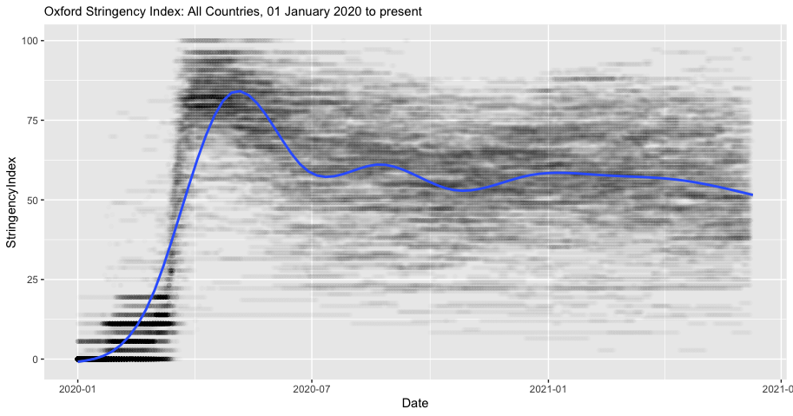  
Figure 2. Oxford Stringency Index with average trendline

(Figure and Analysis by Authors)

**Case studies**

**Viet Nam: Pandemic preparedness and quick government reaction saves lives**

*Introduction*

Viet Nam, a lower-middle income country of 97 million people located in the Asia Pacific region, has been a notable success story for its ability to control the COVID-19 pandemic during the first 12 months of the worldwide outbreak. Yet its success was not assured: Viet Nam shares a 1,300 km land border with China, which accounts for a large proportion of travelers to Viet Nam; the start of the outbreak coincided with the Viet Namese Lunar New Year, when much of the population travels; and two-thirds of the detected cases were asymptomatic [8]. Despite these factors, as of March 1, 2021, Viet Nam had a total of just over 2,000 cases, which corresponds to roughly 3 cases per million people [X]. Nonetheless, the country continues to face imminent threats from imported cases and the emergence of new SARS-CoV-2 variants, particularly in the light of the slow roll-out of COVID-19 vaccines. Viet Nam is currently experiencing a third wave of community transmission, setting in motion a tightening of controls and new testing campaigns in several regions of the country. This reveals the delicate nature of hard-won containment gains and the urgent need for achieving widespread vaccine coverage as key to a sustainable exit from the pandemic.

*Overview of the health system and progress towards UHC*

Viet Nam has a mixed public-private system in which the public system is organized by the Ministry of Health (MoH) in a two-track system focusing on prevention and clinical acute care [9]. The two tracks also span multiple levels ranging from central (Level I), which covers the entire country, to commune (Level IV), which covers fewer than 10,000 people [10]. While the government fully subsidizes premiums for special categories of citizens, including the poor, children under six years of age, and war veterans, the predominant payment method is fee-for-service, wherein fees differ by province and are set jointly by the MoH, the social health insurance agency, and the Ministry of Finance [9].

While Viet Nam has made significant progress towards achieving UHC, it has not yet achieved full coverage of its population. Social health insurance in Viet Nam began as early as 1992, and Viet Nam’s 2008 Law of Health Insurance called for universal coverage by 2014 [9]. However, Viet Nam’s march towards UHC is still incomplete. Although since 2016 Viet Nam had not earmarked a budgetary commitment to UHC, a Lancet study found that UHC was still a high priority budget item; the same study concluded that while Viet Nam had initial programs and systems of implementation for UHC in progress, there was still a need for further systems development and capacity building to reach the population not yet covered [11]. As of 2019, IHME estimated that Viet Nam had achieved 60% effective UHC coverage, an increase of 3-percentage points from 2010 [12].

Viet Nam, along with many countries in Southeast Asia, has been going through rapid development and ever-changing population dynamics. While their economy is also steadily improving, the pace has not yet caught up with its population growth rate, leaving a high proportion of households, mostly concentrated in rural areas, in poverty. In rural areas, including the Northwest and Central Highland regions where remote mountainous communities are predominant and the fertility remains high, maternal and child care quality is suboptimal and the maternal and neonatal mortality rate is almost twice as high as the national average [K]. Fast changing population dynamics, including a high birth rate as well as a rapidly ageing population, creates complicated patterns of infectious diseases and the burdens of both communicable and non-communicable diseases. Uncontrolled immigration from neighboring countries adds to the existing issues Viet Nam’s healthcare system must address [L].

Fig.XX Trend of Selected SDG-3 Indicators Before the COVID-19 Pandemic (2009-2019), Vietnam

Despite all abovementioned challenges, Viet Nam achieved some great progress towards SDG-3 in the past decade. The country publishes an annual report on their progress towards SDG goals jointly with the UN agencies [M]. According to the most recent report published in 2018, between 2000 and 2015, Viet Nam’s effort has been focused on reducing the burden of communicable diseases, including HIV/AIDS and Tuberculosis, whose incidence and deaths have been reduced significantly during the period. Circa 2018, the UN and interagency partners were implementing 77 key activities across various locations in Viet Nam with the common aim to achieve SDG targets [N]. These efforts are representative of a campaign over the past decade to reinforce policy and law related to public health and social welfare. One comparative study compared Viet Nam and China’s public health law coverage and concluded that Viet Nam has a high coverage of public health laws across various topics; these public health laws range from creating social insurance to improving public health [O, P]. While the rural-urban disparities in maternal and child health indicators currently remain as a key issue, Viet Nam has been rolling out generally strong neonatal care guidelines across the country [Q]. Health experts widely consider Viet Nam’s focus on law and policy reinforcement as the most effective approach to building a health system with strong resilience and long-term sustainability.

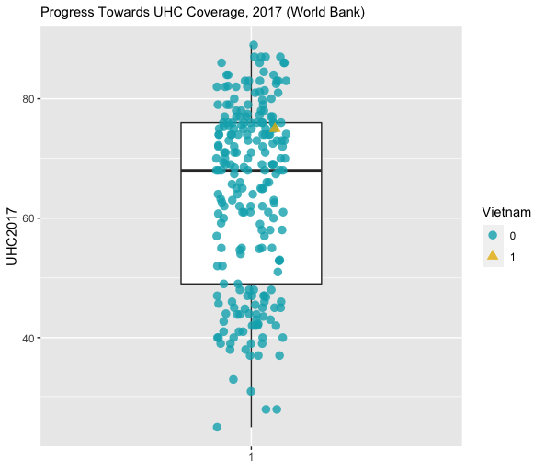

Viet Nam faces three primary health systems related challenges that complicated its response to COVID-19. First, the country generally faces overcrowding in hospitals; according to a recent interview conducted right before COVID, Viet Nam had about 24.5 beds per 10,000 population [9]. Even prior to COVID-19, this led to bed occupancy rates reaching 120%-160%, especially in the central hospitals of some large cities [10]. Second, there is an urban-rural health divide, wherein people living in rural settings often have pre-existing comorbidities and limited access to health services [13]. Third, there is also a shortage of physicians; Viet Nam reported roughly 8 physicians per 10,000 people in 2015 [10]. These factors raised questions of healthcare capacity during COVID-19, and also highlight why Viet Nam focused so much of its efforts during the pandemic on preventing the spread of disease. Although Viet Nam’s progress towards UHC may not account for its success in controlling the pandemic during the first year of the pandemic—instead, Viet Nam’s high level of pandemic preparedness and rapid and swift governmental response seem to have played a larger role—it may help the country recover faster in the aftermath of the pandemic. Moreover, given the country’s current investment in reinforcing the law and policy to build resilient health system, coupled with its experience with the COVID-19, Viet Nam may be able to respond to the next pandemic more effectively. The health system’s future success, however, might rely on how the system expands UHC while facing growing immigration.

*Pandemic preparedness and response capacity*

Over the last few decades, Viet Nam accumulated substantial experience in controlling infectious diseases, including malaria, HIV/AIDS, tuberculosis, and parasitic diseases; as a result of disease surveillance efforts, these diseases have led to markedly fewer premature deaths in the population during this period [cite IHME GBD]. However, Viet Nam’s most pertinent experience was dealing with emerging infectious disease epidemics, notably SARS-CoV-1 in 2003 (Viet Nam was the first country to successfully control Severe Acute Respiratory Syndrome, SARS), Swine Flu (H1N1), and Avian influenza (H5N1) in 2004 [9]. Viet Nam’s fairly recent fight with these epidemics has not only led to institutional-level preparedness and planning capacity for pandemics [14], but also social memory, which may have led to strong public support of regulations and guidance related to COVID-19 and a high degree of adherence to personal and community preventive measures recommended by the government [15].

The WHO’s 2016 International Health Regulations (IHR) Joint External Evaluation (JEE) found that Viet Nam had a high level of capacity in the technical areas of IHR coordination, communication and advocacy, zoonotic diseases, real-time surveillance, and immunization. This is mainly because Viet Nam has made a strategic decision to invest in its public health infrastructure in the aftermath of the SARS epidemic and developed a national public health emergency operations center and a national public health surveillance system. The national center along with four regional centers have since then run exercises and trainings to prepare key stakeholders in government for outbreaks, and have managed preparedness and response efforts for measles, Ebola, Middle East respiratory syndrome (MERS), and Zika. Hospitals are required to report notifiable diseases within 24 hours to a central database, ensuring that the Ministry of Health can monitor epidemiological events across the country. Much of Viet Nam’s response mechanisms is also a by-product of decades of engagement with global health organizations; for instance, the US Centers for Disease Control and Prevention has been working with Viet Nam since 1998, providing input on disease screening, prevention, and laboratory capacity [8]. In 2018, an innovative event-based surveillance program, which empowers members of the public to report unusual public health events, was implemented in collaboration with this agency [B, C]. This is not to say that all levels of government were equally prepared to respond to the COVID-19 pandemic; operational readiness among grassroots health providers was found to be only moderately effective [17]. Additionally, the IHR-JEE review previously noted that there was a need to strengthen multisectoral collaboration, coordination and information sharing, and sustainable investment in health security [16].

*Response to COVID-19*

In mid-January, well in advance of the first COVID-19 case in the country, the government of Viet Nam issued first the national response plan and technical treatment and care guidelines for COVID-19, and then the national surveillance guidelines [B]. This early action resulted in the successful identification of the first two cases on 23 January 2020 and containment of the first community transmission chain in the country. Immediately after, Viet Nam suspended all flights from and to Wuhan, China, and established a national steering committee to prevent and control COVID-19. Contact tracing and quarantine measures (self-quarantine at home and quarantine at non-medical and medical facilities were immediately put into place [D]. When a case was confirmed, the authorities would trace to the fourth contact level from the confirmed case [18]. Further, social distancing measures, face mask use, and in-country travel restrictions were enacted and enforced [19, F]. Further, communication between the government units and between the government and the public was prioritized from the start of the pandemic, with regular updates on outbreak status and government actions. To this end, with the encouragement of the government, a number of mobile applications were rapidly developed and provided free of charge to citizens [G]. Measures were also imposed to prevent hoarding and price-gouging for basic personal protective equipment (PPE) [8]. Further, in February, Viet Nam closed the shared border with China and suspended all flights between the two countries. During the first two months into the pandemic, only 16 cases were reported. From 26 February to 5 March 2020, there were no new confirmed cases of COVID-19.

In early March 2020, cases started to increase in number due to imported COVID-19 cases from Europe and the US [18], and community transmission was indicated due to the identification of cases with no travel history and no apparent contact with COVID-19 patients. As a result, the government put into place a multi-jurisdictional cooperation mechanism between local authorities and health stations to conduct sensitive and broad contact tracing on all passengers in planes that had reported cases of COVID-19. Contact tracing was implemented as a joint effort between the Ministry of Health, the Ministry of Technology and Science, the Ministry of Public Security, the local CDC, and local authorities. Mandatory COVID testing and a 14-day quarantine at a government-run isolation center were required for all international passengers. There were, though, concerns that the implementation of a 14-day quarantine for close contacts of international travelers would lead to a shortage of quarantine space [18]. During this period, all Viet Nam residents were requested to wear a face mask in public places; gatherings of 10 or more people were prohibited; schools were closed; and intracity/intercity movement restrictions were enacted [19]. On March 28, Viet Nam enacted a blanket travel ban for all international flights despite WHO’s advice against travel bans at the time [19]. On 31 March, with the total number of reported cases rising above 200, the Prime Minister called for urgent and stricter measures to halt community transmission, including a 15-day nationwide lockdown, where people were allowed to leave their houses for only essential activities, such as seeking medical care or buying food [E]. This included shutting down non-essential businesses and public transport, allowing only essential travel between cities and provinces, and prohibiting gatherings of more than 2 people in public places. The lockdown was extended for another 15 days in high-risk cities and was in effect until the end of April. In parallel, mass testing for COVID-19 continued, and testing was streamlined with an innovative sampling method where nasal and throat swabs from 2-7 individuals were placed in a single tube at collection. An online system was launched to provide support to all health facilities located in remote areas on medical counseling, consultation, imaging diagnosis, pathology to eliminate geographic and social barriers and enhance diagnosis and treatment capacity for COVID-19 [H]. All these measures were applied with increasing stringency until this second wave of community transmission was successfully brought under control in early June. Testing, treatment and quarantine (food and accommodation) costs were covered by the government [I]. Thereafter, testing and contact-tracing continued, and quarantine measures were enforced vigilantly as new small-scale outbreaks were identified and contained during the rest of the year. As of 21 January 2021, Viet Nam reported 1,521 COVID-19 cases and experienced low mortality rates.

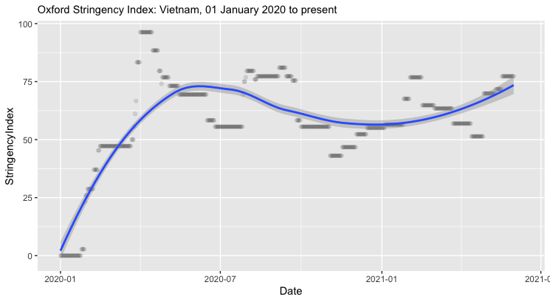

Figure XX. Oxford Stringency Index. Figure and Analysis by the authors.

The success of Viet Nam’s policy response in the first 12 months of the pandemic has been attributed to a variety of factors, including swift policy action of the government due to the nature of its political mechanisms and administrative systems facilitating rapid and effective coordination horizontally across central government units and vertically from central to local levels [J]; the country’s high level of pandemic preparedness as a result of its experiences with past public health crises, long-running engagement with global health organizations and the resulting willingness to follow globally recommended protocols for pandemic response [19]; clear prioritization of public health above economic considerations thorough a “proactive and comprehensive” response by the healthcare system, combined with an energetic and creative public education campaign [22]; mass mobilization of government and civil society organizations in a “whole of society” approach to draw on knowledge and capacities from across multiple sectors and ministries [20, 21]; fostering cooperative national sentiment and solidarity through timely and transparent communication on the outbreak-related developments by the government and the media which fostered trust and credibility of the government among the public [8]; and the country’s adaptation capabilities whereby central and local governments has continually amended and created new policies and has rapidly adjusted and fine-tuned response measures based on scientific and epidemiologic data in response to new outbreaks in the country [8]. While these factors indicate due preparedness, it was the flexibility and capacity to respond rapidly and decisively on pertinent policy areas that helped the country to stay ahead of the pandemic’s progression during the first three waves.

*Conclusion*

Despite being a resource-constrained country, Viet Nam successfully contained the COVID-19 outbreaks during the first year of the pandemic while little was known about the virus. This is in contrast to other countries in Asia with similar levels of economic development, such as India, the Philippines and Indonesia. Viet Nam’s success in handling the COVID-19 pandemic was perhaps attributable more towards its recent experiences with epidemics and ensuing investments in its public health infrastructure, as well as its political and administrative systems that facilitate cooperation within the government units and between the government and the public. The same spirit of the command-and-control architecture of Viet Nam’s political and administrative systems, which facilitated effective coordination and management of activities for the COVID response horizontally and vertically, is also predicted to serve the post-pandemic economic recovery effort through fiscal stimulus and public investment [8, 23]. In the post-pandemic world, Viet Nam’s steady progress towards UHC may play a role in its economic and social recovery from COVID-19.

*Takeaways*

* Viet Nam, a lower-middle income country located in the Asia Pacific region, was highly successful at controlling COVID-19 during the first 12 months of the pandemic
* Viet Nam’s success is attributable to its previous experience combatting epidemics like SARS, high-level of pandemic preparedness, rapid and comprehensive action, and its adaptive capabilities in its COVID-19 response.
* While Viet Nam’s progress towards UHC may not have played a major role in Viet Nam’s successful COVID response, its UHC capacity may enable the country’s successful economic and social recovery from COVID-19

**Peru: When expansion of public health insurance and robust normative framework proves insufficient to tackle a public health crisis**

*Introduction*

Peru is an upper middle-income country in Latin America with over 32 million inhabitants. [ref] The majority (79%) of the population lives in urban areas, with over 30% living around the capital, Lima[ref]. It is administratively divided into 26 departments, with marked health and wealth disparities. Life expectancy at birth in 2020 in the more affluent, mainly urban departments, such as Lima, was estimated at 78 years, compared to 71 years in the poorest, mainly rural departments, such as Huancavelica[ref]. In 2019, 20% of the population lived below the poverty line, with large disparities by residency status; 40% of the rural population lived below the poverty line compared to 15% of the urban population [ref]. In 2019, 73% of the working population of Peru was in informal working arrangements with large disparities by department, ranging from 92% of working people in the department of Huancavelica to 60% in Lima [ref]. The largest informal sectors are fishing, agriculture and commerce. Women make up a disproportionate share of the informal workforce (76% of women vs 70% of men)[ref].

*Overview of the healthcare system and progress towards UHC*

The Peruvian healthcare system is decentralized and includes both public and private services and providers.[ref] The Ministry of Health (MoH) is by far the largest insurer and provider. About 44% of the population is insured by Segura Integral de Salud (SIS, Integral Health Insurance), a government-subsidized healthcare plan. [ref] The services provided by the MoH are further decentralized into national, regional and municipal levels. The introduction of SIS signified a remarkable growth in health coverage, particularly primary care coverage and reduction in out-of-pocket expenditures.[ref] EsSalud, is the second largest body, with 25% of the population affiliated. EsSalud services are regulated and operated by the Department of Labor and Employment, and provides mandatory health coverage for all people employed in the formal sector through their employers. Finally, 6% of the population are affiliated with the Armed Forces, the National Police, and the private sector.[ref]

UHC is promoted under a legal framework in Peru. The Universal Health Insurance Law (Ley Marco del Aseguramiento Universal en Salud), adopted in 2009, stipulates universal health coverage, as well as defines the basic package of services.[ref] Since then, the government has enacted multiple other decrees to continue expanding SIS in an effort to achieve UHC, including expanding SIS inclusion criteria and the essential package of services that are available free of charge to reduce out-of-pocket expenditures, regardless of poverty level. As a result, between 2009 and 2017, healthcare coverage increased significantly from 60.5% to 76.4%.[ref]

An analysis by the civil society alliance to end poverty, identified three main weakness in the healthcare system: 1) fragmentation; 2) low overall health investments, which limits response capacity; and 3) underfunded primary health care, with most investment going to second and tertiary care levels.[ref]

The healthcare system in Peru includes 20,000 healthcare establishments, including over 600 hospitals. However, distribution is uneven, with roughly 67% of hospitals located in Lima. Total health expenditure, including private and public, represents 5.5% of Peru’s gross domestic product on health, which is an improvement from below 3% of GDP until the healthcare reform of 2013. However, these levels are below the Latin American average of 7.7% and below those of most high-income countries.[ref] Healthcare expenditures are shared by the government, employers, and households, although, as of 2019, 60% of health expenditures were in the public sector.[ref] As of 2010, all insurance schemes must cover an essential care package, as regulated by the Plan Esencial de Aseguramiento Universal.[ref] However, because the healthcare system is fractured and not all services are covered or available from each insurer, most households incur out-of-pocket expenses in the form of monthly subscription fees or fee-for-services for non-basic services. As a result, premature death attributed to NCDs remains as a key issue. [ref] High informality in labor markets and the new waves of migrants from Venezuela exacerbated the number of vulnerable populations despite country’s best efforts to expand access to care.[ref] As a result, Peru’s progress towards SDG 3 targets has been slow in the past few years. Peruvian government, in response to this, has recently aligned their overall government agenda to the 2030 SDG targets and has been publishing annual report on its strategic focus and progress.[ref]

Fig.XX Trend of Selected SDG-3 Indicators Before the COVID-19 Pandemic (2009-2019), Peru

*Pandemic preparedness and response capacity*

Coordinated by the MoH’s National Center for Epidemiology, Prevention and Control of Disease (Centro Nacional de Epidemiologia, Prevencion y Control de Enfermedades), Peru has a robust disease surveillance system, with protocols in place for monitoring and mandatory reporting of infectious and non-infectious diseases. [ref] Over 20 diseases and conditions, including infectious diseases that are endemic to some regions of Peru, such as malaria and dengue, as well as for tracking health indictors, such as maternal mortality, are collected by the system. Epidemiologic surveillance of respiratory infections has been included in the system since 2015 against infectious disease outbreaks.[ref] The country’s existing burden of arboviral diseases, including dengue, chikungunya, and Zika, surpassed the country’s medical and public health capacity even before the COVID-19 pandemic. Peru is the third country in Americas with the highest dengue-attributed mortality.[ref] Rapidly changing climate in the region accelerated the spread of mosquito vectors to the areas previously unaffected by the diseases.[ref] The most recent dengue outbreak, started in October 2019 and has spread to 17 regions by the beginning of the COVID-19 pandemic, and it continues to spread as the current report is being drafted.[ref] Early response to this outbreak included the deployment of military force for the fumigation and vector control activities in remote areas due to the shortage of medical workforce. However, this only resulted in short-term decrease in number of cases, which was followed by the re-surge and the declaration of health emergency accordingly.[ref] Unless the preparedness and response capacity is further bolstered, the burden of infectious disease is likely to severely hamper Peru’s progress on population health as number of other mosquito-borne diseases, including Zika and chikungunya, are also steadily increasing.[ref] Industrial development and deforestation can potentially alter and further complicate the dynamics of arboviral diseases, which should be anticipated by the strong preparedness capacity.[ref]

*Response to COVID-19*

The first COVID-19 case in Peru, an imported case with travel history to Europe, was reported on March 5, 2020.[ref] As of June 2021, almost 2 million people have tested positive for COVID-19 and 188,100 have died,[ref] a lethality of 9.4%, with large disparities by department,[ref], largely due to limited access to treatment for severe COVID-19, such as intensive care units, access to oxygen, and mechanical ventilators. Despite the country’s efforts to expand the healthcare coverage in the past decade, 24% of Peruvians remained uninsured before the start of the COVID-19 pandemic.[ref] At the beginning of the COVID-19 pandemic, only 2,000 beds in intensive care units were available nationally.[ref] That is 2.9 beds per 100,000 people, which is lower than the regional average of 9.4 beds per 100,000.[ref] The government acted relatively quickly in response to the COVID-19 pandemic, declaring a national health emergency on March 15, 2020, only 10 days after the detection of the first case.[ref] Yet, from the emergency declaration until May 25, 2020, all primary care provision was closed, creating an immense access barrier to everyone including those who are insured. [ref] The COVID-19 pandemic hit hardest the vulnerable populations in Peru. As of June 2021, the government has also officially recognized the death of 559 medical staff between March and December 2020 while providing care for COVID. [ref] As of May 2021, there was an 43% increase in maternal deaths, with COVID-19 being the leading cause.[ref] In response to the increase in maternal death, government launched a hybrid service model in May 2020 and provided over 10,500 teleconsultations to pregnant women. [ref]

Investment in the public health sector was reinforced, with an emergency budget approved for COVID-19 activities, such as surveillance, testing and tracing, purchase of ICU beds, and personal protective equipment, among others. Healthcare workers involved in the COVID-19 response received monetary incentives. The government also instituted mandatory reporting of COVID-19 cases.[ref] On April 16, 2021, the government launched the national COVID-19 vaccination plan, initially for people over 80 years old, which has been progressively extending to younger people and people at high risk for severe COVID-19 throughout the country.[ref] As of June 14, 2021, over 5 million people received at least one dose of the vaccine.[ref] In order to counter the limited access to necessary care during the pandemic, the government passed an emergency measure to allow more people to be affiliated with SIS, “SIS para todos” (SIS for all). This permitted having more than one type of insurer, expanded the types of services covered, including for treatment for COVID-19, and allowed flexibility in which establishments to visit.[ref] As a result, the official statistics as of October 2020 showed that 95.2% of the population was insured, reducing the uninsured to 5% of the population. [ref]

Aside from the public health measures, including the social distancing, lockdowns, and border closures, the government has issued around 100 decrees related to the economy and labor, education, transportation, rights, and health to prevent and curtail the adverse effects of the pandemic. [ref] An early analysis of the impact of the COVID-19 pandemic in Peru suggested that close to 30% of the population would be living in poverty as a result of the economic impact of COVID-19.[ref] To mitigate the impact, the government issued monetary incentives to households in poverty. In addition, special efforts have been made to contain the impact of the pandemic on hard-to-reach areas in the Amazon rainforest through the Plan de Intervención para Comunidades Indígenas y Centros Poblados Rurales de la Amazonía frente a la emergencia de la COVID-19. [ref]

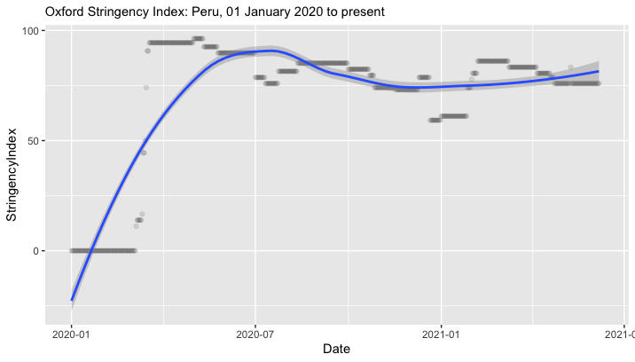

*Conclusions*

Peru’s strength in its health system can be summarized as the expansive health insurance coverage, close to achieving UHC, and the robust normative framework to ensure the system’s resilience to crises. This served as a solid backbone that enabled the country to adapt to the pandemic with agility and flexibility. Their successful expansion of the government-funded insurance scheme and the expansion of telehealth to address the urgent maternal health gap during the early pandemic mitigated, to some degree, the harmful public health consequences of the access barrier caused by COVID-19. The same success, however, was not achieved in controlling other simultaneous infectious disease outbreaks. Despite the country’s commitment and success in achieving UHC and leveraging both the public and private scheme, the country’s toll on COVID-19 pandemic was severe. The damage was disproportionately allocated to the vulnerable groups, such as those in hard-to-reach areas, workers in informal employment, and pregnant women. Peru serves as a good example to signify the importance of the balance between 1) resilient health system with universal coverage, 2) equitable access to health care that is inclusive of vulnerable populations, and 3) the country’s strong emergency preparedness, which includes surveillance, sufficient volume of trained medical and public health workforce, as well as laboratory capacity. In January 2021, the Peruvian government issued a decree to refine the definition of telehealth and its purpose, aiming to continue expanding the telehealth model and its associated legal frameworks beyond the pandemic, following its success in tackling the maternal health issue.[ref] Post-pandemic, the next steps for Peru would be to continue expanding the telehealth model to tackle some of the key challenges surfaced during the pandemic, including strengthening linkages with primary and secondary care, reducing the disparity in access to care for the vulnerable, and to build resilient health care system against public health crises.

*Take-aways*

* Peru’s strength in health system can be attributed to their quick action to expand the public health insurance during the pandemic to achieve UHC. This was only possible with the strong foundation of the previous 10 year’s achievement in increasing access to health care. Peru’s expanded coverage close to UHC was an essential enabler to promoting access to life-saving procedures.
* Peru’s robust legal framework on health systems enabled the government to be resilient in the face of this public health crisis. The country has continued to strengthen its normative and legal framework during COVID-19 and allowed healthcare institutions to reorganize services.
* Peru has also demonstrated the potential of telehealth services beyond the COVID-19 pandemic. As evidenced by their success story in tackling maternal health, telehealth is a promising strategy to replace in-person visits, while still providing life-saving services and preventing infections among providers and healthcare users.
* On the other hand, Peru’s failure to effectively control the COVID-19 pandemic stems from two main factors:

1. The weak response capacity to infectious disease outbreaks, including the shortage of staff, insufficient geographical coverage of public health and medical services, and the suboptimal laboratory capacity.
2. Rapidly changing population and disease dynamics due to the highly volatile labor market, migration, and climate change, whose speed is difficult to catch even for the agile government.

* In sum, Peru serves as a good example to signify the importance of the balance between 1) a resilient health system with universal coverage, 2) an equitable access to health care that is inclusive of vulnerable populations, and 3) a strong country-level emergency preparedness.

**Oman**

* *Introduction*
* *Overview of the health system and progress towards UHC*

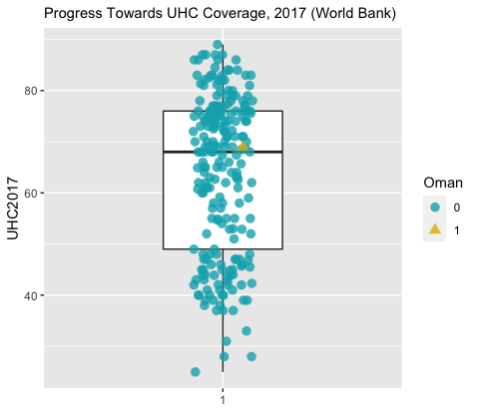

Fig.XX Trend of Selected SDG-3 Indicators Before the COVID-19 Pandemic (2009-2019), Oman

* *Pandemic preparedness*
* *Response to COVID-19*

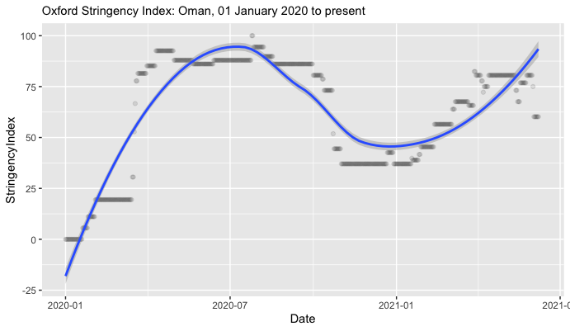

* *Conclusion*
* *Takeaways*

**Nigeria**

* *Introduction*
* *Overview of the health system and progress towards UHC*

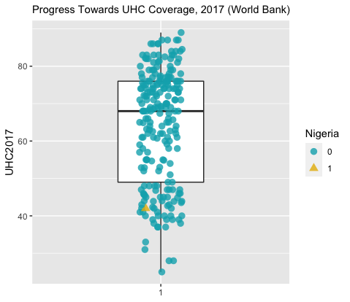

Fig.XX Trend of Selected SDG-3 Indicators Before the COVID-19 Pandemic (2009-2019), Nigeria

* *Pandemic preparedness*
* *Response to COVID-19*

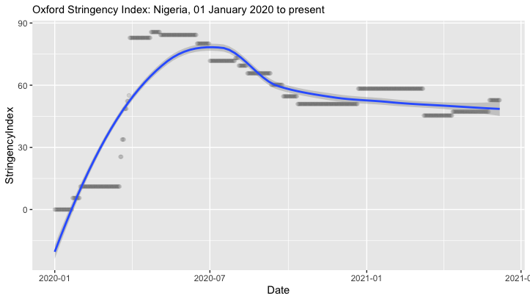

* *Conclusion*
* *Takeaways*

**Rwanda**

* *Introduction*
* *Overview of the health system and progress towards UHC*

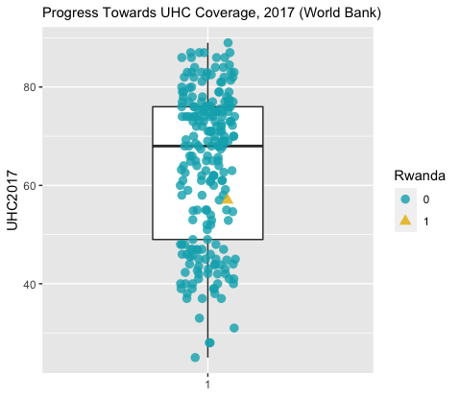

Fig.XX Trend of Selected SDG-3 Indicators Before the COVID-19 Pandemic (2009-2019), Rwanda

* *Pandemic preparedness*
* *Response to COVID-19*

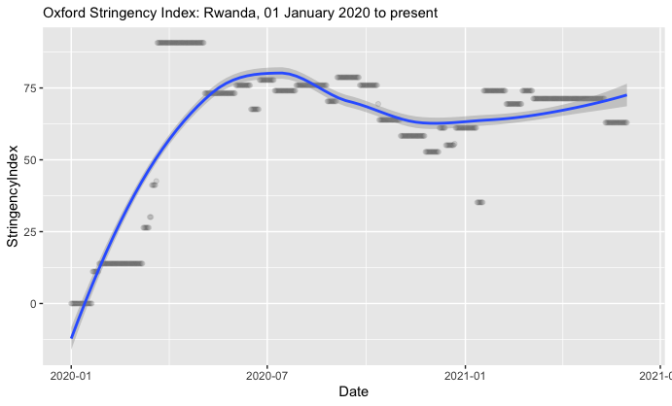

* *Conclusion*
* *Takeaways*

**Comparative analysis**

* Initial findings have identified that limiting gatherings to fewer than 10 people, closing high-exposure businesses, and closing schools and universities were more effective policies than stay-at-home orders [24]. We find that this makes sense in the context of our inquiry, specifically that the case studies indicate that governments’ abilities to both quickly initiate and then enforce these policies—or have societies that are amenable to adherence with these policies on their own volition—was integral to their ability to contain the COVID-19 pandemic.

*Pandemic responses in resource-constrained settings*

* Counterintuitively, the economic strength of a country can delay necessary government action to address the pandemic [25].

*Primary similarities and differences in policies and approaches across countries*

*What has been effective?*

* Fiscal expenditures on health, regional and local government capacity, and pressure on a health system can accelerate government responses [25].

*The role of UHC coverage*

*Key policy lessons*

**Conclusion**

* Impact of COVID-19 on health systems
* COVID-19 pandemic will speed up adoption of digital public service provision [26], possibly including other public service provisions including a transition to UHC.

**Works Cited**

1. Cheng, C., et al., *COVID-19 government response event dataset (CoronaNet v. 1.0).* Nature human behaviour, 2020. **4**(7): p. 756-768.

2. Hale, T., et al., *Variation in government responses to COVID-19.* Blavatnik school of government working paper, 2020. **31**: p. 2020-11.

3. Mintrom, M. and R. O’Connor, *The importance of policy narrative: effective government responses to Covid-19.* Policy Design and Practice, 2020. **3**(3): p. 205-227.

4. Hale, T., et al., *A global panel database of pandemic policies (Oxford COVID-19 Government Response Tracker).* Nature Human Behaviour, 2021. **5**(4): p. 529-538.

5. Kansiime, M.K., et al., *COVID-19 implications on household income and food security in Kenya and Uganda: Findings from a rapid assessment.* World development, 2021. **137**: p. 105199.

6. Walker, P., et al., *Report 12: The global impact of COVID-19 and strategies for mitigation and suppression.* 2020.

7. Goodman, M.P., S. Segal, and M. Sobel, *Assessing the G20 Virtual Summit.* Center for Strategic and International Studies, 2020. **27**.

8. Hartley, K., S. Bales, and A.S. Bali, *COVID-19 response in a unitary state: emerging lessons from Vietnam.* Policy Design and Practice, 2021. **4**(1): p. 152-168.

9. Cheng, T.-M., *Vietnam’s health care system emphasizes prevention and pursues universal coverage.* Health Affairs, 2014. **33**(11): p. 2057-2063.

10. Takashima, K., et al., *A review of Vietnam’s healthcare reform through the Direction of Healthcare Activities (DOHA).* Environmental health and preventive medicine, 2017. **22**(1): p. 1-7.

11. Reich, M.R., et al., *Moving towards universal health coverage: lessons from 11 country studies.* The Lancet, 2016. **387**(10020): p. 811-816.

12. Murray, C.J., et al., *Global burden of 87 risk factors in 204 countries and territories, 1990–2019: a systematic analysis for the Global Burden of Disease Study 2019.* The Lancet, 2020. **396**(10258): p. 1223-1249.

13. Tran, B.X., et al., *Health status and health service utilization in remote and mountainous areas in Vietnam.* Health and quality of life outcomes, 2016. **14**(1): p. 1-9.

14. Thu, H.L., *Vietnam: A Successful Battle Against the Virus.* Asia Unbound (New York: Council on Foreign Relations), 2020.

15. Hartley, K. and D.S. Jarvis, *Policymaking in a low-trust state: Legitimacy, state capacity, and responses to COVID-19 in Hong Kong.* Policy and Society, 2020. **39**(3): p. 403-423.

16. Organization, W.H., *Joint external evaluation of IHR core capacities of Viet Nam: mission report: 28 October-4 November 2016*. 2017, World Health Organization.

17. Tran, B.X., et al., *The operational readiness capacities of the grassroots health system in responses to epidemics: Implications for COVID-19 control in Vietnam.* Journal of global health, 2020. **10**(1).

18. Nguyen, T.H. and D.C. Vu, *Summary of the COVID-19 outbreak in Vietnam–Lessons and suggestions.* Travel medicine and infectious disease, 2020.

19. Quach, H.-L. and N.-A. Hoang, *COVID-19 in Vietnam: A lesson of pre-preparation.* Journal of Clinical Virology, 2020. **127**: p. 104379.

20. Black, G., *Vietnam may have the most effective response to Covid-19.* The Nation, 2020. **24**.

21. Dabla-Norris, E., A.-M. Gulde-Wolf, and F. Painchaud, *Vietnam’s Success in Containing COVID-19 Offers Roadmap for Other Developing Countries.* IMF Country Focus, 2020.

22. Hoang, V.M., et al., *Describing the pattern of the COVID-19 epidemic in Vietnam.* Global health action, 2020. **13**(1): p. 1776526.

23. Morisset, J., *Vietnam: Potential Policies Responses to the COVID-19 Epidemic*. 2020, World Bank.

24. Brauner, J.M., et al., *Inferring the effectiveness of government interventions against COVID-19.* Science, 2021. **371**(6531).

25. González-Bustamante, B., *Evolution and early government responses to COVID-19 in South America.* World development, 2021. **137**: p. 105180.

26. Agostino, D., M. Arnaboldi, and M.D. Lema, *New development: COVID-19 as an accelerator of digital transformation in public service delivery.* Public Money & Management, 2021. **41**(1): p. 69-72.

**Works to be cited:**

1. Yan, Bo, et al. "Why do countries respond differently to COVID-19? A comparative study of Sweden, China, France, and Japan." *The American Review of Public Administration* 50.6-7 (2020): 762-769.
2. Thai PQ, Rabaa MA, Luong DH, Tan DQ, Quang TD, Quach HL, Hoang Thi NA, Dinh PC, Nghia ND, Tu TA, Quang N, Phuc TM, Chau V, Khanh NC, Anh DD, Duong TN, Thwaites G, van Doorn HR, Choisy M; OUCRU COVID-19 Research Group. The First 100 Days of Severe Acute Respiratory Syndrome Coronavirus 2 (SARS-CoV-2) Control in Vietnam. Clin Infect Dis. 2021 May 4;72(9):e334-e342. Doi: 10.1093/cid/ciaa1130. PMID: 32738143; PMCID: PMC7454342.
3. US Centers for Disease Control and Prevention (CDC). Vietnam update: community-based surveillance yields results. Updates from the Field. 2017;25:10. <https://www.cdc.gov/globalhealth/healthprotection/fieldupdates/summer-2017/vietnam-community-surveillance.html>.
4. The Vietnamese Ministry of Health, 2020. The Vietnamese Ministry of Health Decision No. 878/QĐ — BYT on the circulation of guidelines on quarantine in health establishments Hanoi, Vietnam (2020)
5. Tuan D. The Prime Minister agreed to continue implementing Directive 16 at least until April 22 in Some localities Government Electronic Newspaper – Government Portal. (2020) Available from: <http://baochinhphu>.vn/Tin-noi-bat/Thu-tuong-nhat-tri-tiep-tuc-thuc-hien-Chi-thi-16-it-nhat-den-224-tai-mot-so-dia-phuong/393140.vgp
6. Prime Minister. 06/CT-TTg: Strengthening Preventive and Control. Measures Against New Complications of Acute Respiratory Infections Caused by New Strains of Corona Virus. Hanoi: (2020).
7. The Vietnamese Ministry of Health. 2020. <https://ncovi.vn/>
8. Tran TPT, Le TH, Nguyen TNP, Hoang VM. Rapid response to the COVID-19 pandemic: Vietnam government's experience and preliminary success. *J Glob Health*. 2020;10(2):020502. doi:10.7189/jogh.10.020502
9. Quach and Thi, 2020. H.L. Quach, N.A.H. Thi. COVID-19 in Vietnam: a lesson of pre-preparation. J Clin Virol (2020), Article 104379
10. COVID-19 response in a unitary state: emerging lessons from Vietnam. [Hartley, Kris, Bales, Sarah, Bali, Azad Singh](https://pesquisa.bvsalud.org/global-literature-on-novel-coronavirus-2019-ncov/?lang=en&q=au:%22Hartley,%20Kris,%20Bales,%20Sarah,%20Bali,%20Azad%20Singh%22). Policy Design and Practice ; : 1-17, 2021.
11. <https://data.unicef.org/wp-content/uploads/country_profiles/Viet%20Nam/country%20profile_VNM.pdf>

<https://publications.iom.int/system/files/pdf/sa-migrant-health-viet-nam.pdf>

<https://sustainabledevelopment.un.org/content/documents/19967VNR_of_Viet_Nam.pdf>

<https://vietnam.un.org/en/sdgs/3>

<https://globalizationandhealth.biomedcentral.com/articles/10.1186/s12992-019-0472-z>

<https://sustainabledevelopment.un.org/content/documents/19967VNR_of_Viet_Nam.pdf>

Raven, Joanna, et al. "Using guidelines to improve neonatal health in China and Vietnam: a qualitative study." *BMC health services research* 16.1 (2016): 1-13.